**AIRBNB CASE STUDY METHODOLOGY**

**INTRODUCTION**

Airbnb is a company that offers visitors, travellers, and tourists an internet platform for lodging. It offers a wide range of rooms and homestays that are hosted by individuals who have registered as Airbnb hosts. These rental properties include apartments, homes, and boats in various neighbourhoods all over the world. Property rates vary by location and region, as well as neighbourhood and room availability.

New York City is one of the most popular tourist destinations, attracting visitors from all over the world. Properties that cater to various needs based on pricing.

**OBJECTIVE**

For the past few months, Airbnb has seen a major decline in revenue. Now that the restrictions have started lifting and people have started to travel more, Airbnb wants to make sure that it is full prepared for this change and what are the following parameters required to increase the revenue

**ABOUT THE DATASET**

The dataset has been downloaded from upgrad student portal

1. The data set depicts the listing activity and analytics in New York City. It contains information about the hosts, their regional availability, as well as reviews and ratings. It features 16 columns with information such as the host id, host name, latitude and longitude, reviews, room type, 365-day availability, and so on.

**ANALYZING THE DATASET**

We have used Tableau application to analyse the database to gain insights about different Airbnb properties in New York.

1. Basically there are five neighbourhood groups in New York, where the Airbnb are present and there are as follows Manhattan, Brooklyn, Queens, Bronx and Staten Island

|  |  |
| --- | --- |
| **Neighbourhood Group** | **Properties** |
| Staten Island | 373 |
| Bronx | 1,091 |
| Queens | 5,666 |
| Brooklyn | 20,104 |
| Manhattan | 21,661 |
| **Total Airbnb’s** | **48895** |

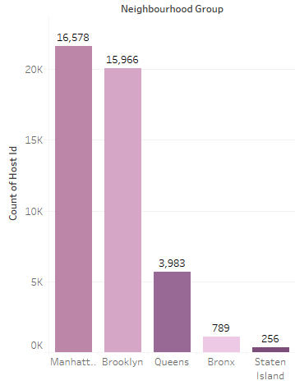

1. There are total 37752 Airbnb’s in New York, while some of the properties belong to a similar host and number of hosts present in each area are as follows:

|  |  |
| --- | --- |
| **Neighbourhood Group** | **Hosts** |
| Staten Island | 256 |
| Bronx | 789 |
| Queens | 3,983 |
| Brooklyn | 15,966 |
| Manhattan | 16,578 |

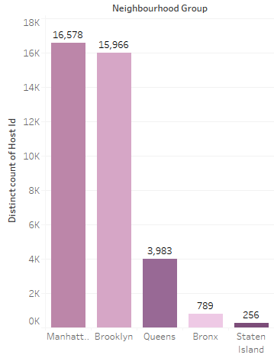

1. The most number of properties are in these areas:

|  |  |  |
| --- | --- | --- |
| **Neighbourhood** | **Neighbourhood Group** | **Properties** |
| Upper West Side | Manhattan | 1,971 |
| Bushwick | Brooklyn | 2,465 |
| Harlem | Manhattan | 2,658 |
| Bedford-Stuyvesant | Brooklyn | 3,714 |
| Williamsburg | Brooklyn | 3,920 |

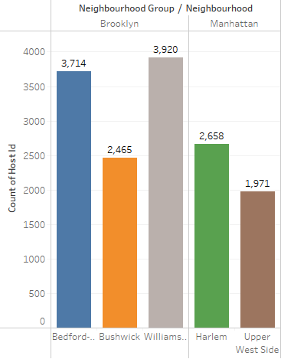

Here we can see that most number of properties are in Williamsburg, followed by Bedford-Stuyvesant and are located at Manhattan and Brooklyn.

1. Here we can see that we have three types of rooms:
2. Entire Home/Apt
3. Private Room
4. Shared room

Here the average price of the rooms costs:

|  |  |  |
| --- | --- | --- |
| **Room Type** | **Avg. Price** | **Properties** |
| Entire home/apt | $211.79 | 25,409 |
| Private room | $89.78 | 22,326 |
| Shared room | $70.12 | 1,160 |

1. The most number of sales has been covered by Entire Home/Apt which accounts for 72.07% of the whole sales.
2. The Top 10 locations based on price are as follows:

|  |  |
| --- | --- |
| **Neighborhood** | **% based on Sales** |
| Williamsburg | 15.22% |
| Midtown | 11.79% |
| Upper West Side | 11.22% |
| Hell's Kitchen | 10.82% |
| Bedford-Stuyvesant | 10.79% |
| East Village | 9.31% |
| Upper East Side | 9.17% |
| Harlem | 8.54% |
| Chelsea | 7.50% |
| Bushwick | 5.64% |

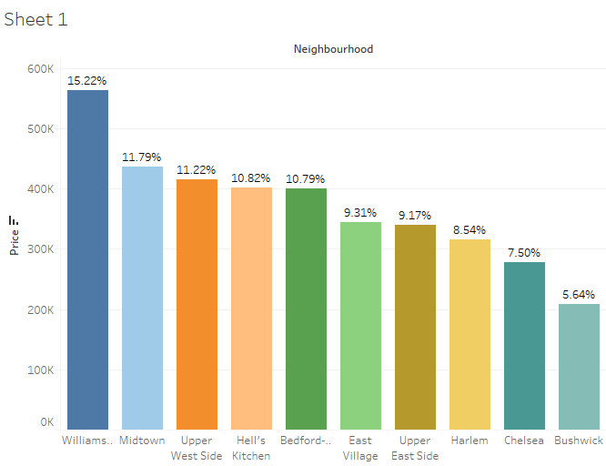

1. Top 10 most reviewed Hosts are:

|  |  |
| --- | --- |
| **Host Name** | **Number of Reviews** |
| Alex | 6,204 |
| Anna | 4,799 |
| Chris | 5,028 |
| Daniel | 4,723 |
| David | 8,103 |
| Eric | 4,733 |
| Jason | 6,522 |
| John | 7,223 |
| Michael | 11,081 |
| Sarah | 4,579 |

Here we can see that top 10 hosts has got more than 4000 reviews.

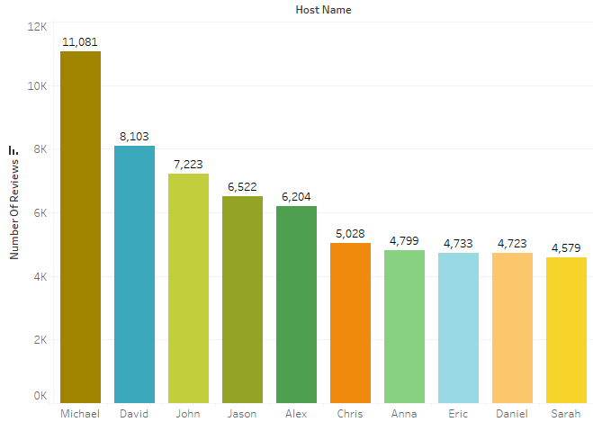

1. Sales for Room Type Preference based on Neighborhood

|  |  |  |  |
| --- | --- | --- | --- |
| **Room Type** | Bronx | Brooklyn | Manhattan |
| **Entire home/apt** | $48,325.00 | $1,704,633.00 | $3,289,707.00 |
| **Private room** | $43,546.00 | $775,099.00 | $932,111.00 |
| **Shared room** | $3,588.00 | $20,868.00 | $42,709.00 |
|  |  |  |  |

Here we can see that Entire home/Apt is preferred the most, and the least is Shared Room.

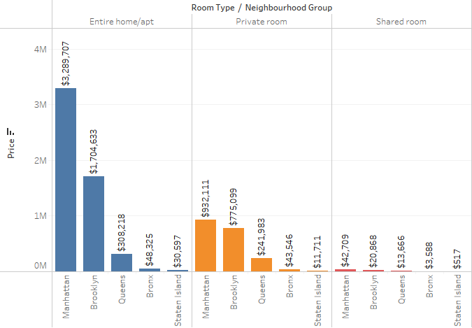

1. Average Price according to the Neighbourhood groups in Airbnbs

|  |  |  |
| --- | --- | --- |
| **Neighbourhood Group** | **Neighbourhood** | **Average Price** |
| Bronx | Riverdale | $442.09 |
| Brooklyn | Sea Gate | $487.86 |
| Manhattan | Tribeca | $490.64 |
| Staten Island | Fort Wadsworth | $800.00 |
| Queens | Breezy Point | $213.30 |

1. Top 15 locations based on customer preference:

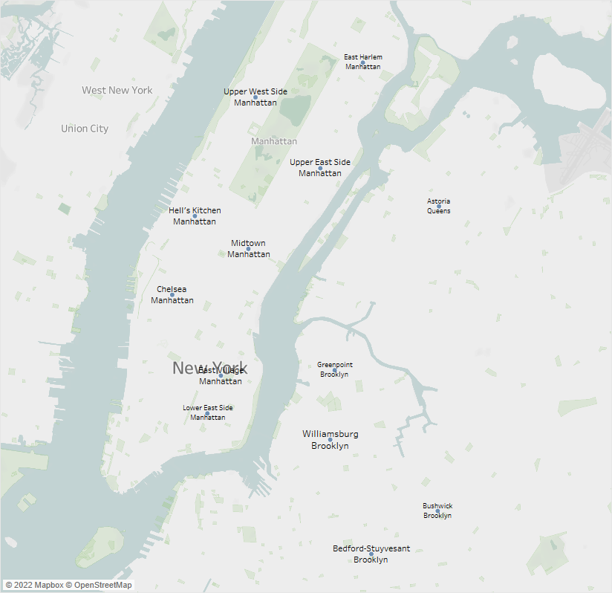

Here we can see that most of the airbnb’s are located in Brooklyn and Manhattan and accounts for maximum number of sales through these top 15 airbnb’s.

1. Number of Reviews for each Neighbourhood groups

|  |  |
| --- | --- |
| **Neighbourhood Group** | **Number of Reviews** |
| Bronx | 1,091 |
| Brooklyn | 20,104 |
| Manhattan | 21,661 |
| Queens | 5,666 |
| Staten Island | 373 |

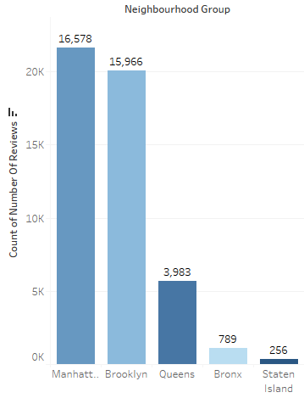

**INFERENCES**

**INFERENCES AFTER ANALYSING THE DATA:**

* It was seen that people like to visit the center of New York from where they can see the beauty of the city.
* The number of listings of shared rooms is limited but their average price is placed less and availability is high.
* A number of reviews and reviews per month were more at lesser price as compared to the higher price as there is lesser chance of people going for a high price room.
* Minimum number of night spent is at Bushwick
* Sales is the highest from Williamsburg, as it falls in Brooklyn, as people prefer Brooklyn more due to its scenic beauty.
* Manhattan and Brooklyn are the most reviewed neighbourhood_groups.
* Manhattan and Brooklyn are very costly neighnourhood_groups.
* Most number of reviews is received by Host Name Dona and its located at Queens.
* People show interest in the host Blueground and spend more nights here. The minimum number of nights to stay reduces with a price increase.
* Entire home/apartment has been reviewed the most while the least being the shared room.
* Around 37 properties are available half of the year, the property is available with around 150 days of the year. They are situated in Brooklyn and Manhattan.
* Average price of Fort Wadsworth at Staten Island is the highest and lowest at Queens
* Most number of Entire home/apt is at Williamsburg while private rooms are most at Bedford-stuyvesant.
* To Focus on the prime locations: Manhattan and Brooklyn where people have shown interest after analysing.